QUERIES and OUPUT

MYSQL QUERIES and OUTPUT

1. Find agents who receive commissions between 0.12 and 0.14 (begin and end values are included). Return agent_code, name, city, and commission.

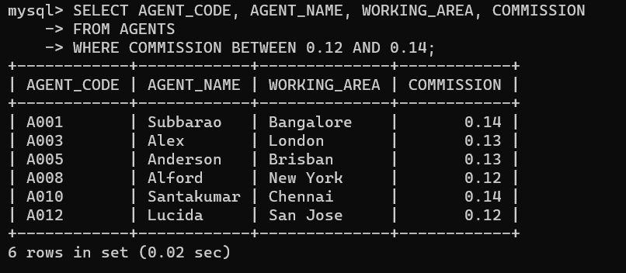

1. 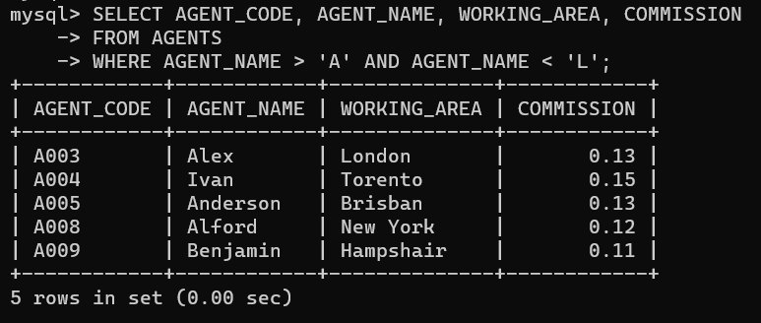Retrieve the details of the agent whose names begin with any letter between 'A' and 'L' (not inclusive). Return agent_code, name, city, commission.
2. Find all those customers who do.es not have any grade. Return customer_id, cust_name, city, grade, agent_code.

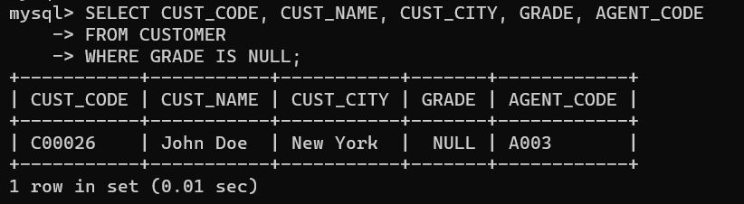

1. Find the highest purchase amount ordered by each customer. Return CUST_CODE, maximum purchase amount.

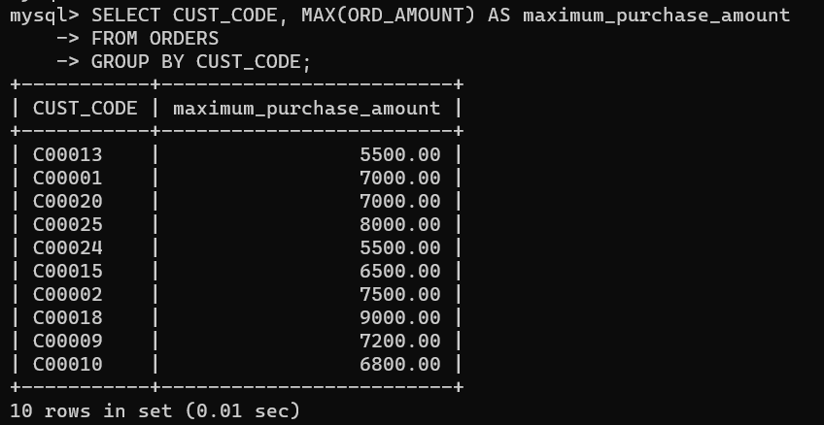

1. Calculate total purchase amount of all orders. Return total purchase amount.

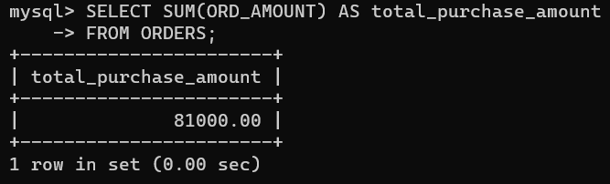

1. Determine the number of customers who received at least one grade for their activity.

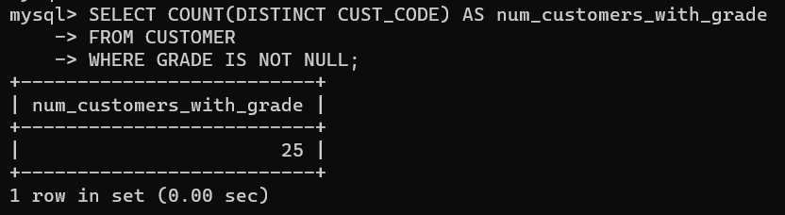

1. Find the highest purchase amount ordered by each customer on a particular date. Return, order date and highest purchase amount.

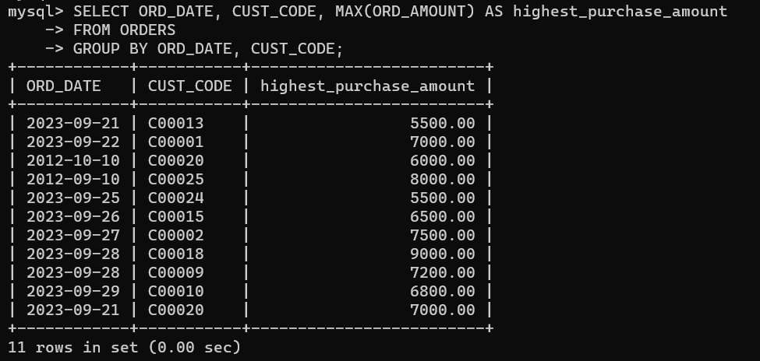

1. Find the highest order (purchase) amount by each customer on a particular order date. Filter the result by highest order (purchase) amount above 2000.00. Return CUST_CODE, order date and maximum purchase amount.

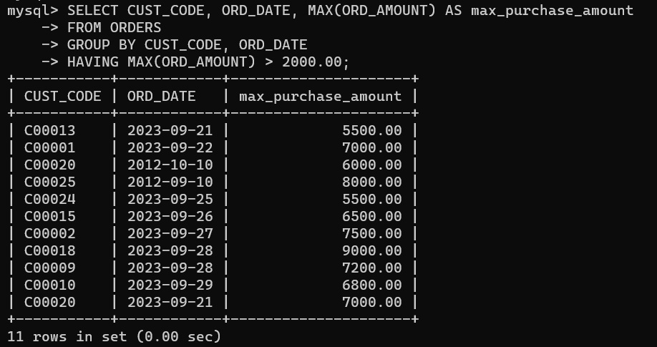

1. Count all the orders generated on '2012-08-17'. Return number of orders.

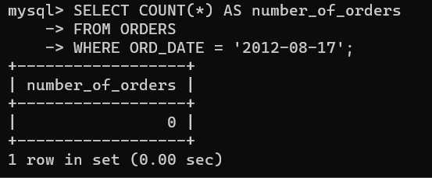

1. Find those agents who generated orders for their customers but are not located in the same city. Return ORD_NUM, cust_name, cust_code (orders table), agent_code (orders table).

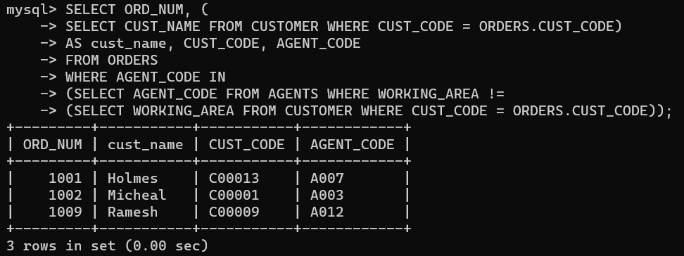

1. Find those customers who are served by a salesperson and the salesperson earns commission in the range of 12% to 14% (Begin and end values are included.). Return cust_name AS "Customer", city AS "City".

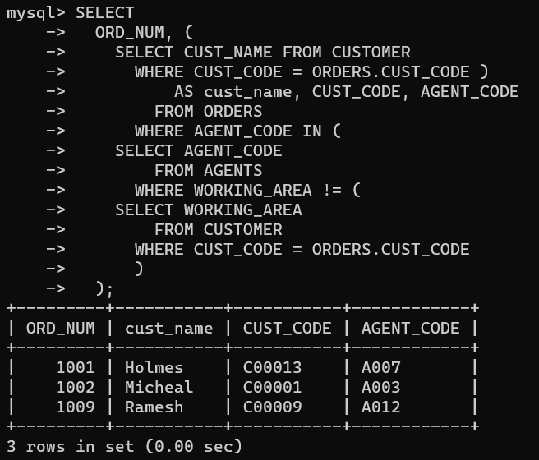

1. Find all orders executed by the salesperson and ordered by the customer whose grade is greater than or equal to 200. Compute purch_amt*commission as “Commission”. Return customer name, commission as “Commission%” and Commission.

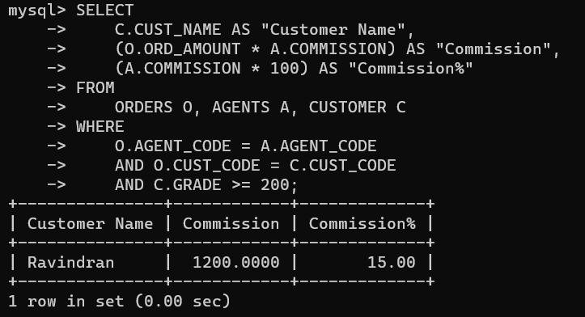

1. Find the order values greater than the average order value of 10th October 2012. Return ord_no, purch_amt, ord_date, cust_code, agent_code.

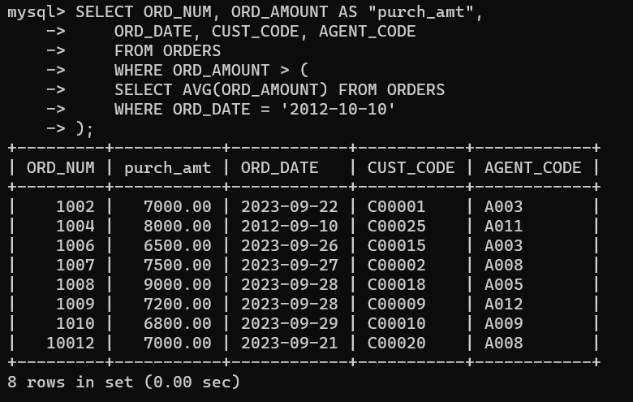

1. Find the sums of the amounts from the orders table, grouped by date, and eliminate all dates where the sum was not at least 1000.00 above the maximum order amount for that date.

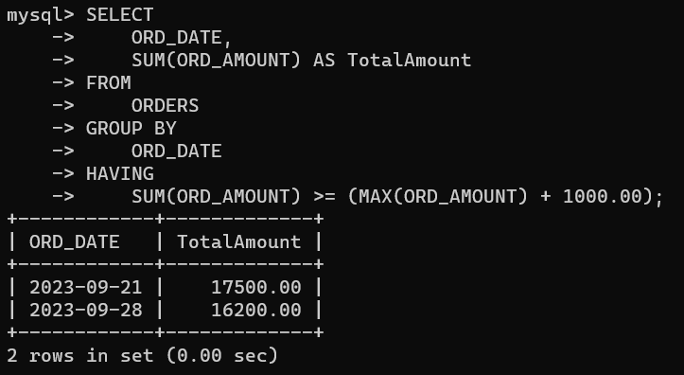

1. find details of all orders excluding those with ord_date equal to '2012-09-10' and agent_code higher than 5005 or purch_amt greater than 1000.Return ord_no, purch_amt, ord_date, cust_code and salesman_id.

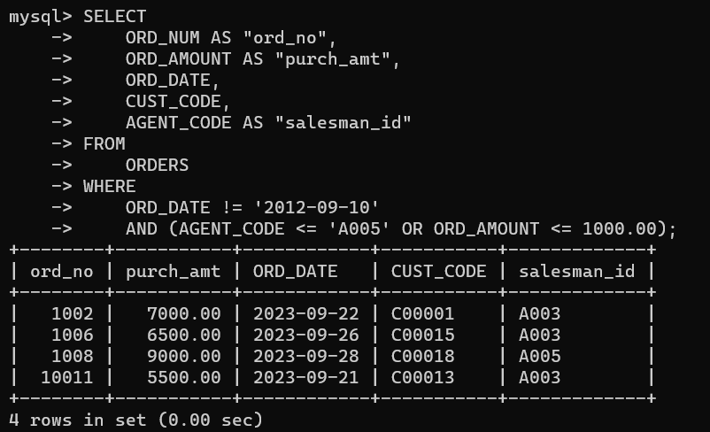

MONGODB QUERIES and OUTPUT

1. Select the restaurant Id, name and grades for those restaurants which returns 0 as a remainder after dividing the score by 7.

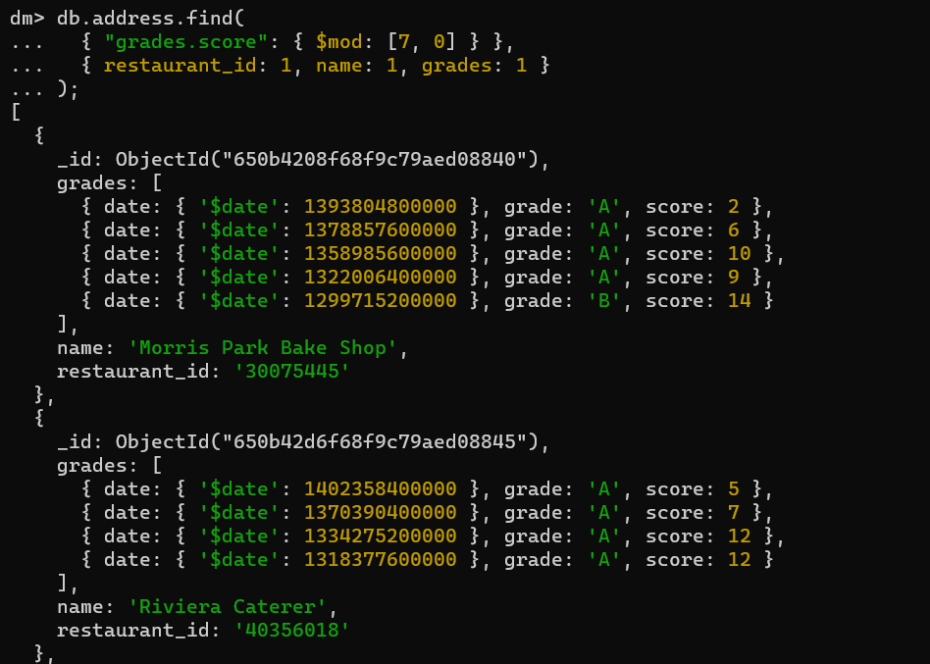

1. Find the restaurant name, borough, longitude and attitude and cuisine for those restaurants which contains 'mon' as three letters somewhere in its name

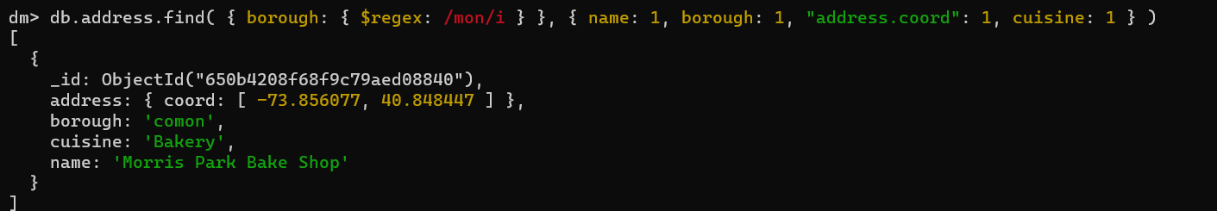

1. Find the restaurants that have at least one grade with a score of less than 5 and that are located in the borough of Manhattan.

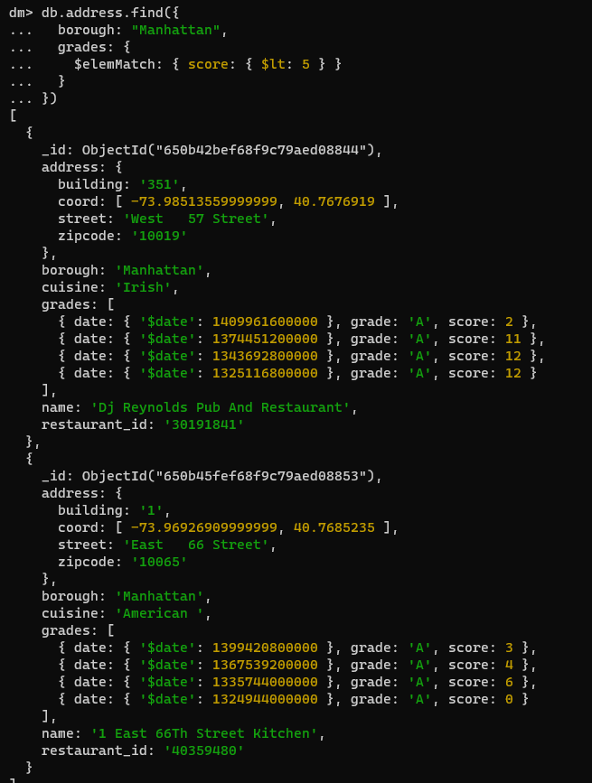

1. Find the restaurants that have at least one grade with a score of less than 5 and that are located in the borough of Manhattan or Brooklyn, and their cuisine is not American or Chinese.

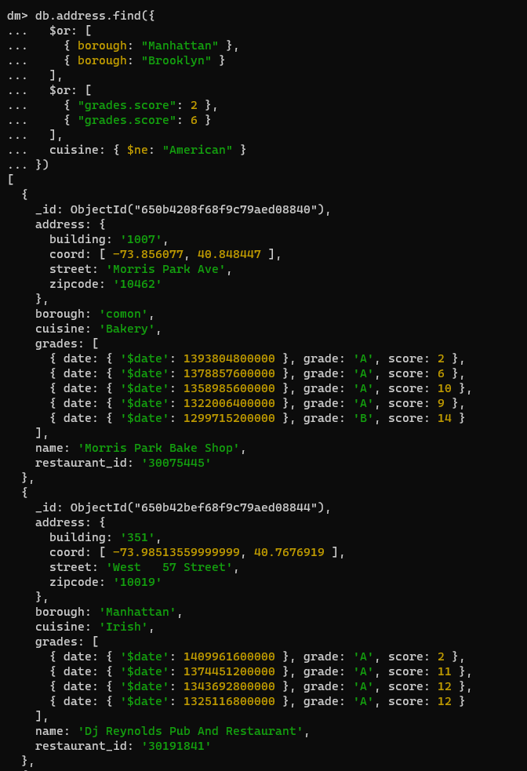

1. Find the restaurants that have a grade with a score of 2 or a grade with a score of 6 and are located in the borough of Manhattan or Brooklyn, and their cuisine is not American.



1. Find the average score for each restaurant.

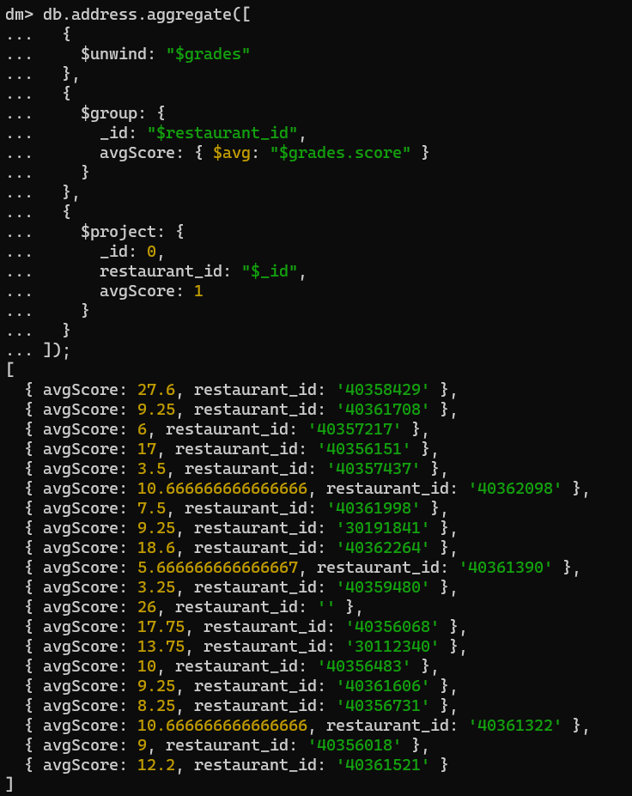

1. Find the count of restaurants for each cuisine.

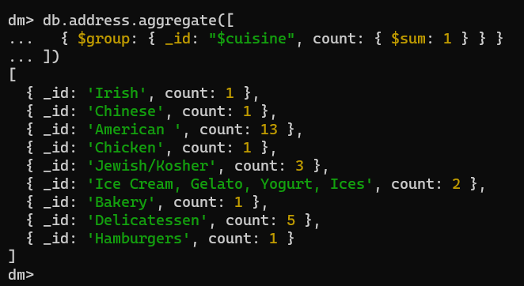

1. Find the count of restaurants that received a grade of 'A' for each cuisine.

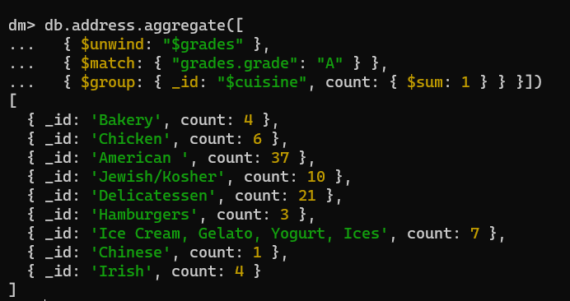

1. Find the number of restaurants that have been graded in each month of the year.

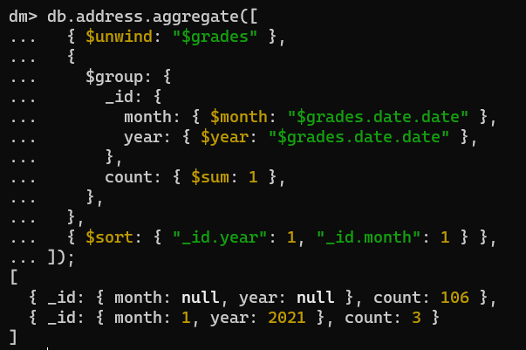

1. Find the name and address of the restaurants that received a grade of 'A' on a specific date.

